4.9 Aggregate data

Key points

Dataflow Gen2
- In a Dataflow Gen2, you can click Group By in the ribbon, to see the following configuration options:
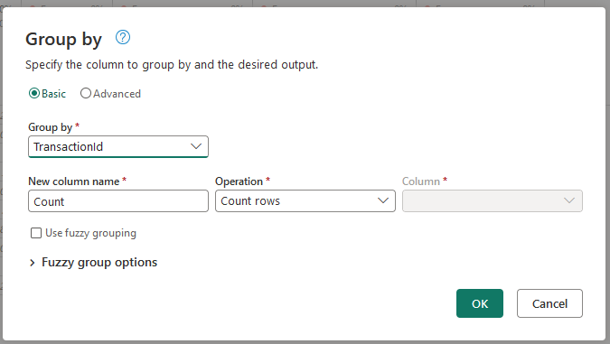

T-SQL Data Warehouse
- Aggregating data using T-SQL is done using the GROUP BY syntax, and an aggregate function (such as MIN(), MAX(), SUM()). This is an example whereby I am grouping by the customer_city_id column, and performing a COUNT() aggregation:
SELECT customer_city_id
, COUNT(customer_id) AS 'total_customers'
FROM raw.hubspot_contacts
GROUP BY customer_city_id
ORDER BY COUNT(customer_id) DESC
